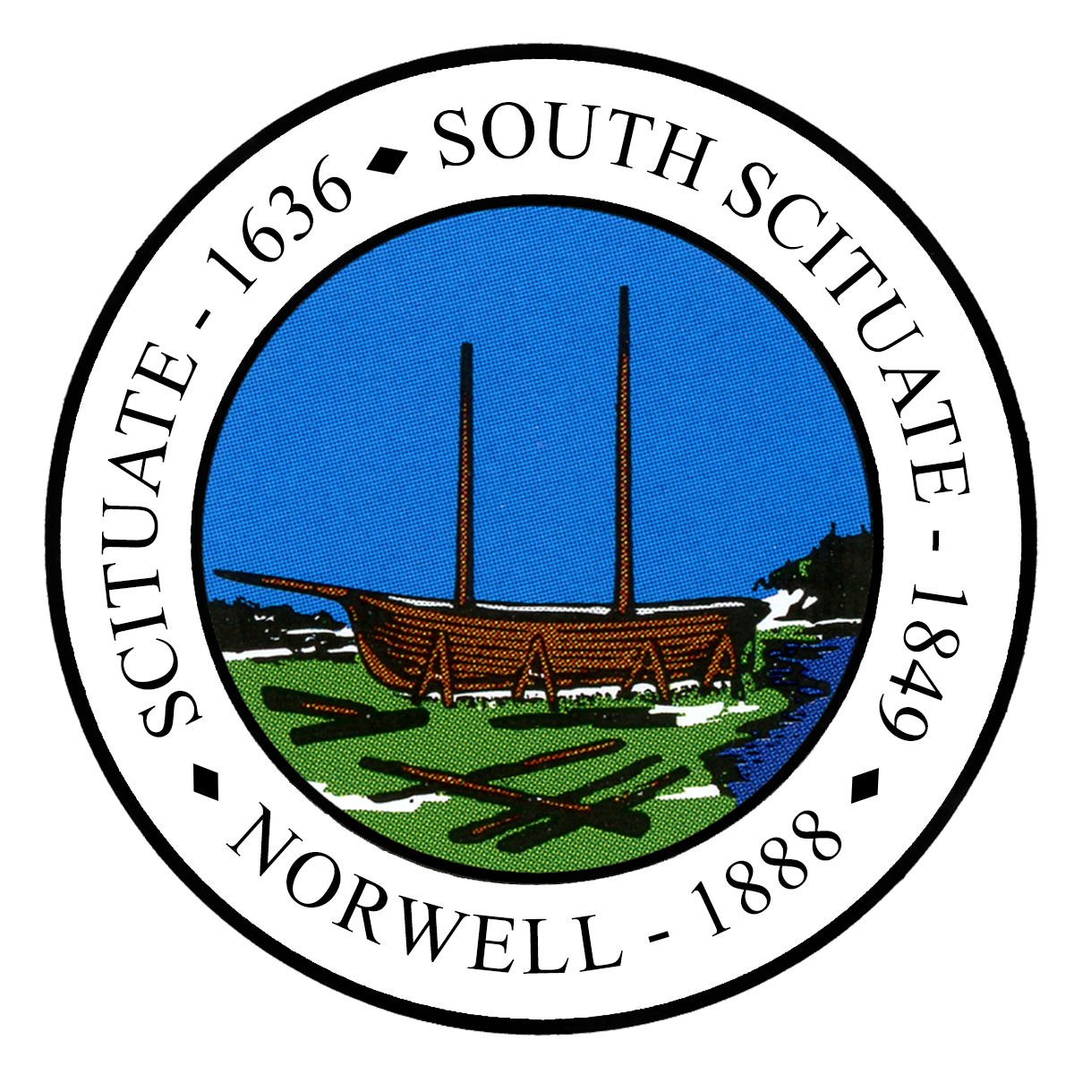
NORWELL CONSERVATION COMMISSION
DAMON FARMS (Washington Street)
July 19, 2023 @ 4:00PM
AGENDA

4:00PM:

On-Site Walk in preparation of Certificate of Compliance Request for:

Damon Farm (Washington Street) / SE52-802 & NCC# 72(05) / (40B) Residential Development
Applicant: Damon Farms, LLC / Representative: Jeffrey Tocchio, Drohan, Tocchio & Morgan

