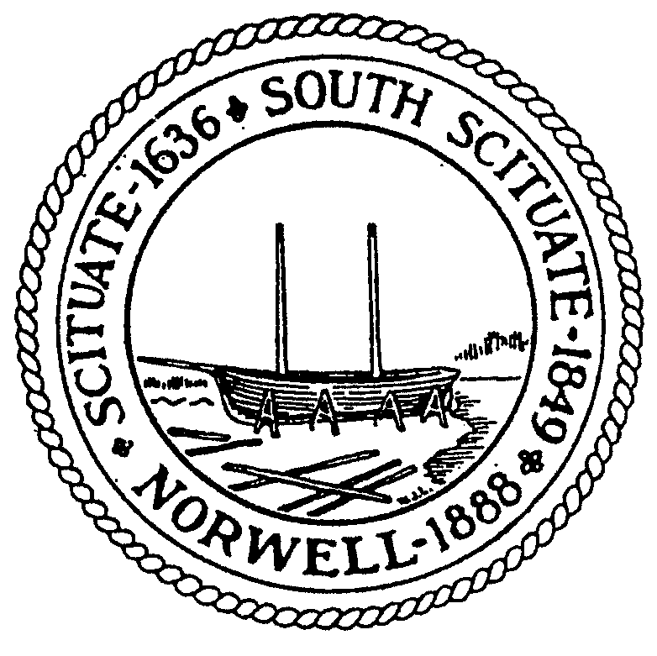Town of Norwell
Board of Assessors
345 Main Street
Norwell, MA 02061
(781) 659-8012

Request For a Certified List of Abutters

Required By Department:

Board of Selectmen Board of Health Highway / Tree & Grounds

Board of Appeals Planning Board Town Clerk

Building Department Conservation Commission

Requested By:

Email:

Telephone: Fax:

Property Location: Map(s): Block(s): Lot(s):

Property Address:

Owner of Record:

Purpose of List:
(Example: Liquor License, Class II Auto, Junk Dealer, Special Permit, Subdivision, OSRD, Scenic Road, etc.)

Requirement: 100-ft. Radius 300-ft. Radius 500-ft. Radius

Direct Adjoining Street Approval

Board of Assessor’s Office Date

